Ecommerce website report:

|  |
| --- |
| **Module: SOFT20181** |
| **Tutor Name:**  **Temi Alade** |
| **Assessment: Web development assignment** |
| **Name/Type: Coursework** |
| **Student Name: Ahmed Abdiqadir Dahir** |
| **Student Number: T0269931** |

Documentation

I hereby declare that I am the sole author of this report

Signature

~~Ahmed~~

Ahmed Abdiqadir Dahir.

**Introduction:**

This is a report about the ecommerce website to be created in the module Internet application.

E-commerce stands for electronic commerce which is the buying and selling of goods and services, or the transfer of funds or data via an electronic network, most notably the internet.

An E-commerce website necessitates a successful design and implementation strategy.

Everything is required to plan from the beginning to the end of the website. The e-commerce sector has seen exponential growth

The e-commerce website will offer online shopping for a variety of products.

Fashion products are housed in a single web space.

The ecommerce website is a clothing website for men only. It consists of 6 pages i.e., home page, I also included a products page, cart page, user page , thumbnail page, add to products page and a contact us page.

I also made the website responsive. Its responsive for all devices starting from my laptop to all devices that have a lower pixel. I tried as hard as possible to make the website to be responsive for all devices, but I was not able to finish doing that because it was time consuming.

I made my website using HTML, CSS and JavaScript. I also made use of the JavaScript library called jQuery.

**Success points:**

I was able to include most of the functionalities that are required for the website.

|  |  |  |
| --- | --- | --- |
| **Success Criteria Point** | **Priority** | **Implemented?** |
| Navigation links | Required | Yes, horizontal navigation bar page across all pages at the top. One can tell the page they are on because the colour of the navigation link changes to pink |
| Registration form | Required | Yes, a page which has a registration form. I have also validated the form whereby the user can see error messages whenever he makes  Mistakes. |
| Responsive design | Required | Yes, the page is responsive for some devices. |
| Toggle menu | Required | Yes, in responsive mode, a toggle menu appears which when the user clicks on it the navigation links will show up. |
| Add to cart | Optional | Yes, a button that will appear whenever we hover over its product card |
| Total update | required | Yes, the total amount in cart can change automatically whenever the user changes the quantity or removes item from cart |
| Form page | Required | Yes, a form page where admin manager can add products |
| Products added with database | Required | Yes, the details inputted in the add products page will be saved in the database and then be displayed in the products page by retrieving the information that is in the database. |
| User creating account | Required | Yes the user is able to create an account with his email address |
| User control | Required | Yes, some pages are restricted for some users only i.e Admin manager can access certain pages which the user cannot |
| Admin manager account | Required | Yes, admin manager will be able to add products to the products page and also remove certain user details from the database. |
| Cart page | Required | Yes, user can add products in cart |

**Initial research:**

The website would be very simple to navigate and use, with navigation bars that link to each section and product, as well as links that send the user to those sections and products, making it easy to move around my website and find the information desired.

I'll include relevant graphics, such as a photo of the costumes. I wouldn't use any unnecessary visuals because some users may become irritated by the use of unnecessary graphics. This website is intended for people aged 15 and up.

my features will include:

1. A navigation bar that will have 5 links which will take the user to the appropriate page he wants
2. In comparison to other websites, it will be responsive and have a toggle menu bar which function will be to show the navigation links in smaller screen devices.
3. Animation will be added

**Initial design:**

The figures below will illustrate my ideas for the ecommerce website:

Site map:

**IMPLEMENTATION**

The main objective of the assessment is to develop an online fashion brochure system. The system aims to achieve the following objectives:

• To design a fashion system.

• To create an avenue where people can navigate and search for fashion products.

• To develop a database to store information on fashion products and services.

Customer Side:

• Customer can view/search products without login.

• Customer can also add/remove product to cart without login (if customer try to add

same product in cart. It will add only one)

•Customer is able to create an account.

•Customer is able to search for products in the product page.

•Customer is able to login.

Administrator Side

• After login, there is a dashboard where admin can see how many customers is

Registered.

• Admin can add/view the products.

• Admin can delete the products.

• Admin can update/edit the products.

• Admin can delete user details after they create an account.

• Admin can change user details after they create an account.

• Admin can delete users.

Home page.

I have divided my homepage(that is the index.html page) into five sections with the <section> elements. I used <footer> element for my footer. I also used the <section> element for the product cards in two sections of the page.

The first section of the page was also divided into two section with <section> element dividing the navigation links and the welcome part of the page.

The articles I wrote were displayed with the <p> tag for paragraphs and the headers were contained with the <h1> tag. The button displayed were contained with the <a> tag which will send you to an appropriate page upon clicking.

Upon hovering over the navigation links of the other pages colour changes to pink. The colour of the navigation link of page changes to pink showing the user the page he currently is in.

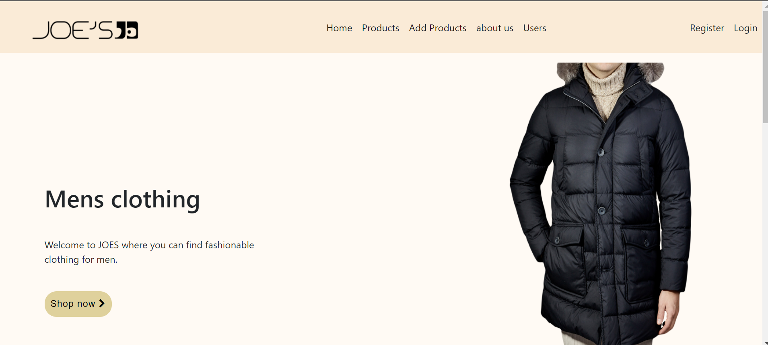

The navigation links register and login changes once the user logs in.

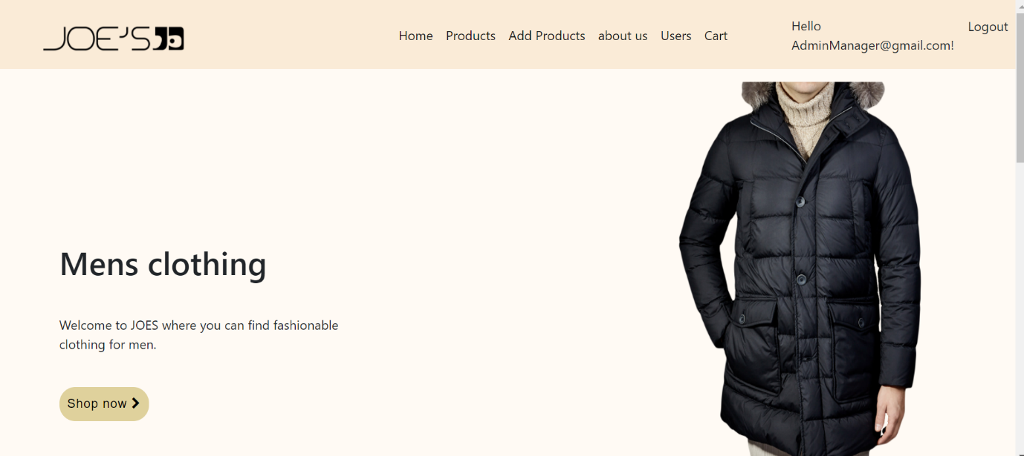

I used also used C# to create the featured products using the list method. I added product information to list and retrieved them in the html tags.

E.g.

public List<Product> products { get; set; }

products = new List<Product>{

new Product()

{

Id = 01,

Name = "Brown Coat",

Description = "...",

ProductImage = "image/barca.jpeg",

Price= 50

}

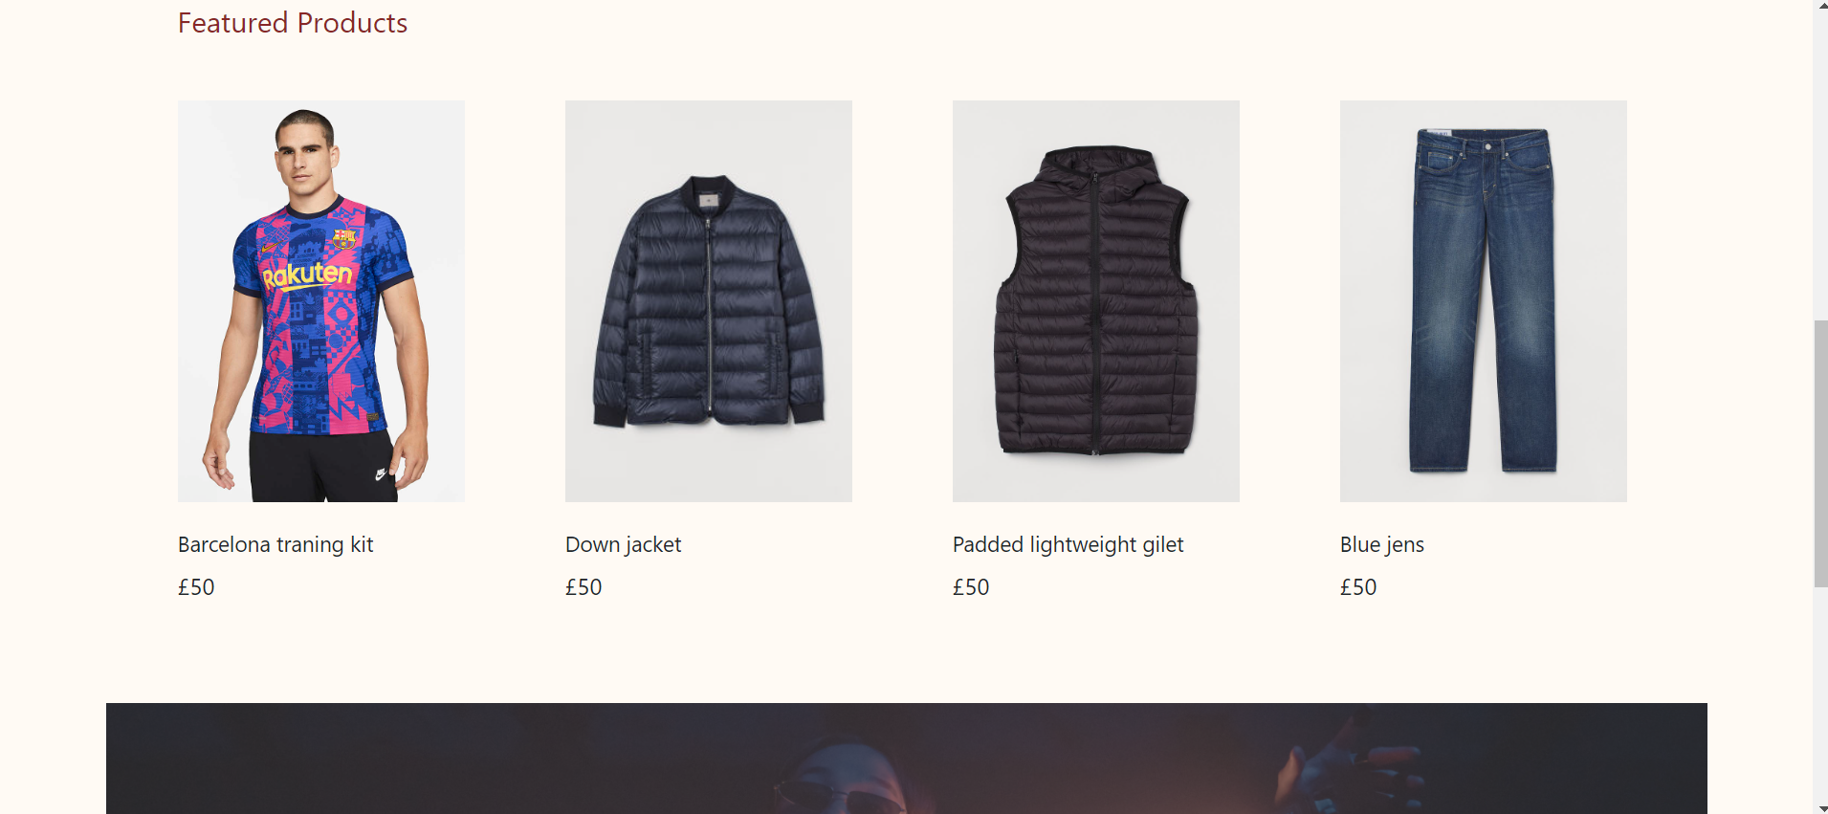

Add products page

I have used the add products page to add forms which will add product information to the database

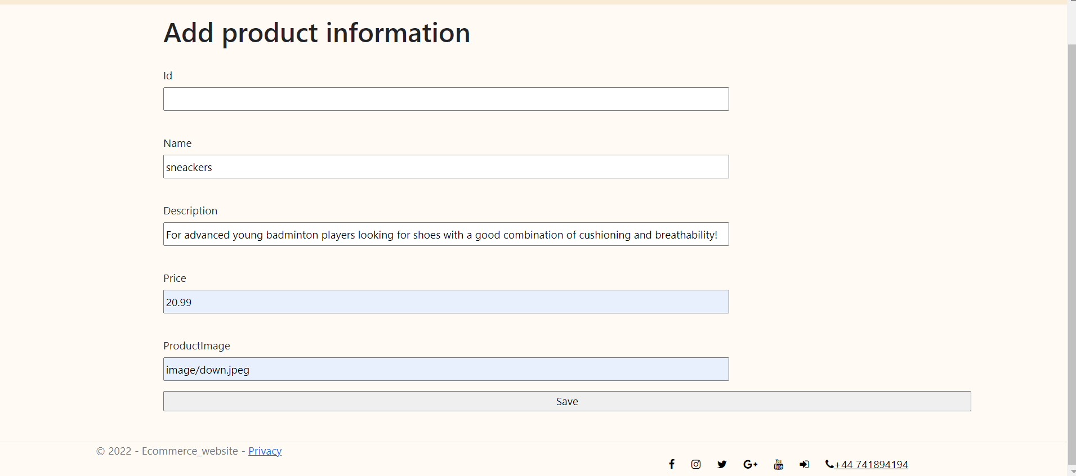

Products page

The products page retrieves product information from the database and displays them in as product cards.

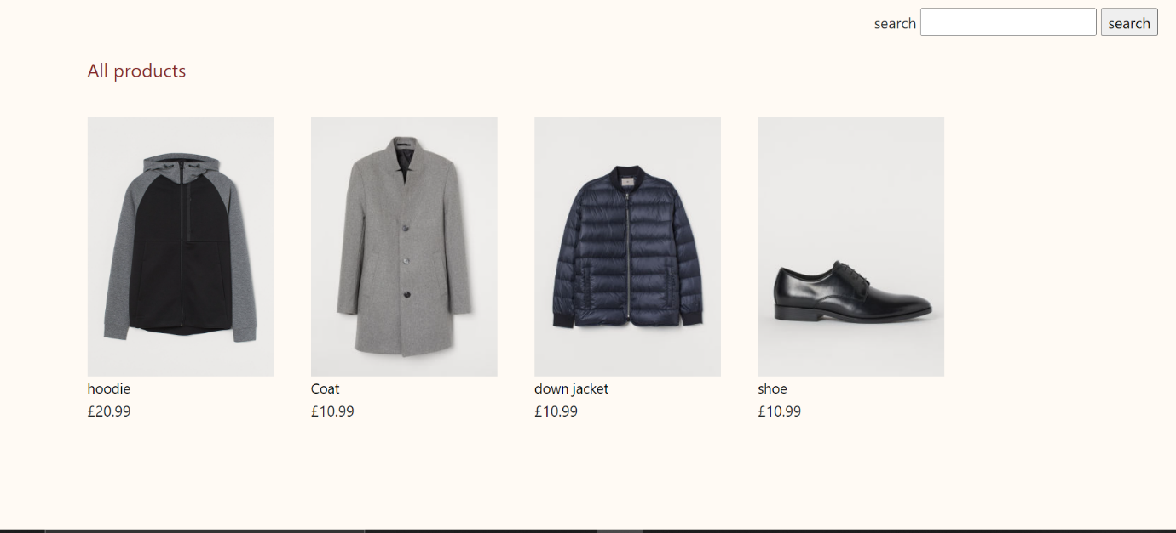

The admin manager is able to access the delete and update button once logged in which delete the product card and update it respectively.

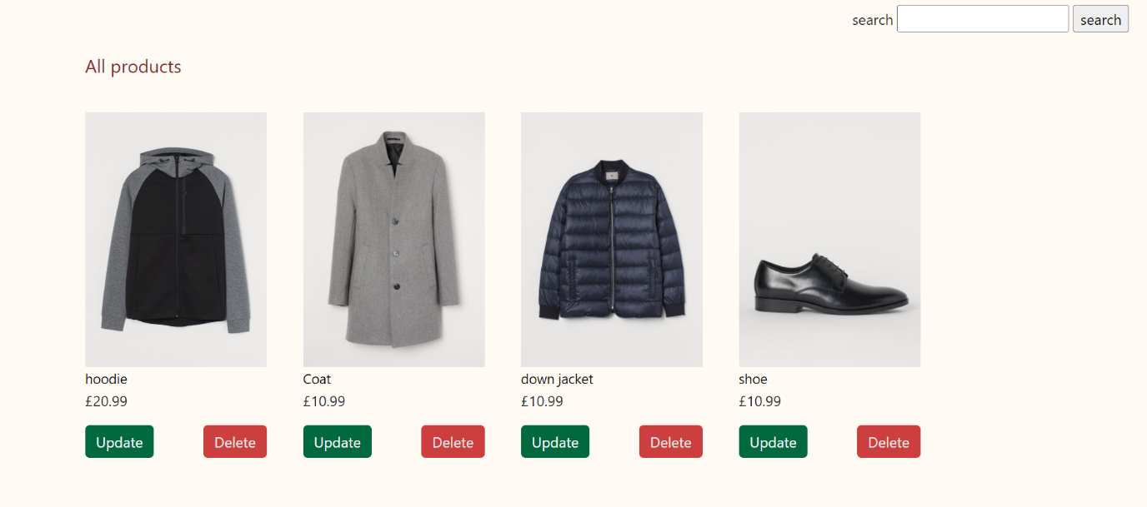

When the admin manager clicks on the update button, it takes him to the add products page.

The product details is displayed in the form boxes together with its id and then the admin manager can change the product details

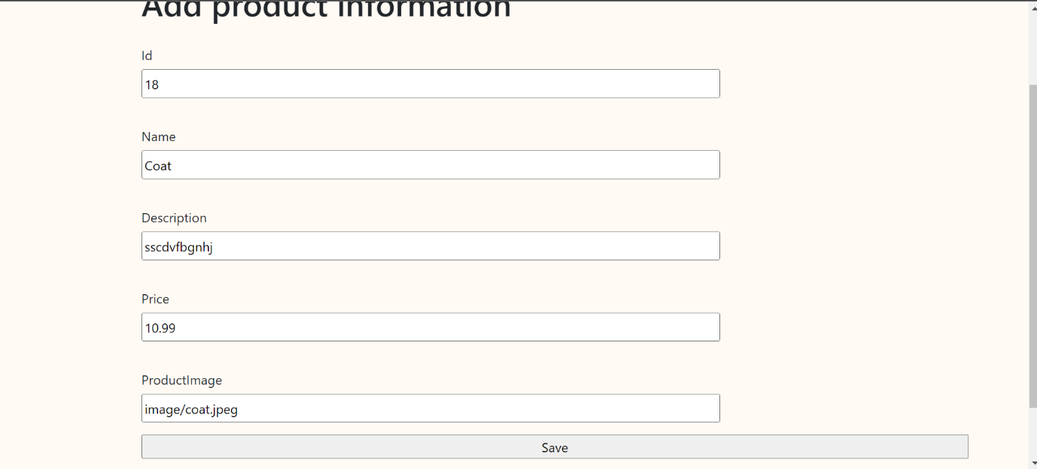

When the user clicks on the products it takes him to the products image thumnail where he can click the buy now button to add products into the cart page.

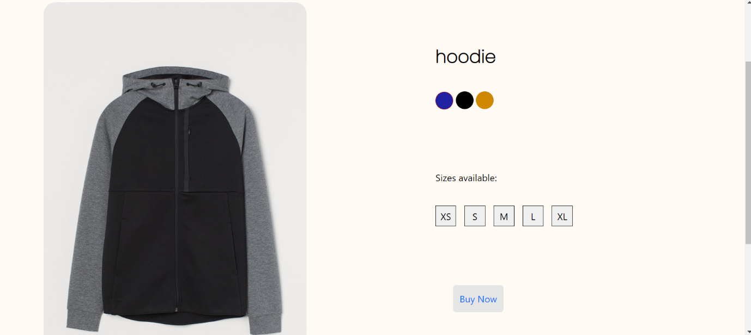

I’ve used the asp net core session for implementing the cart page. The user is also able to delete products from the cart.

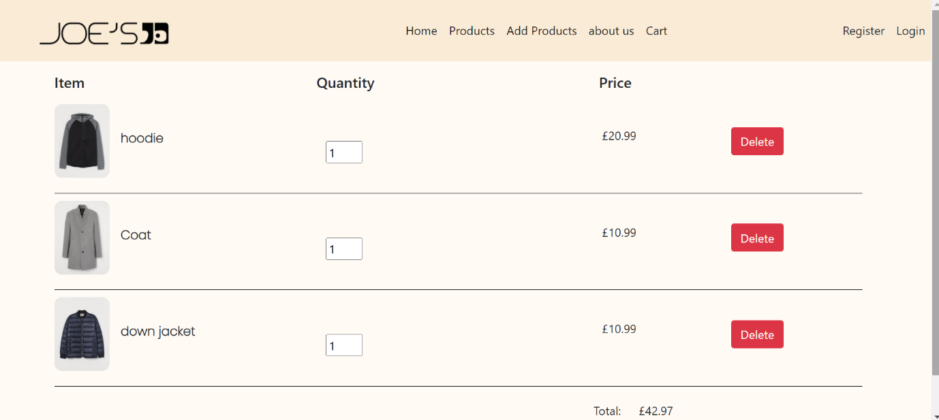

The users page allows admin manager to delete users information from the database

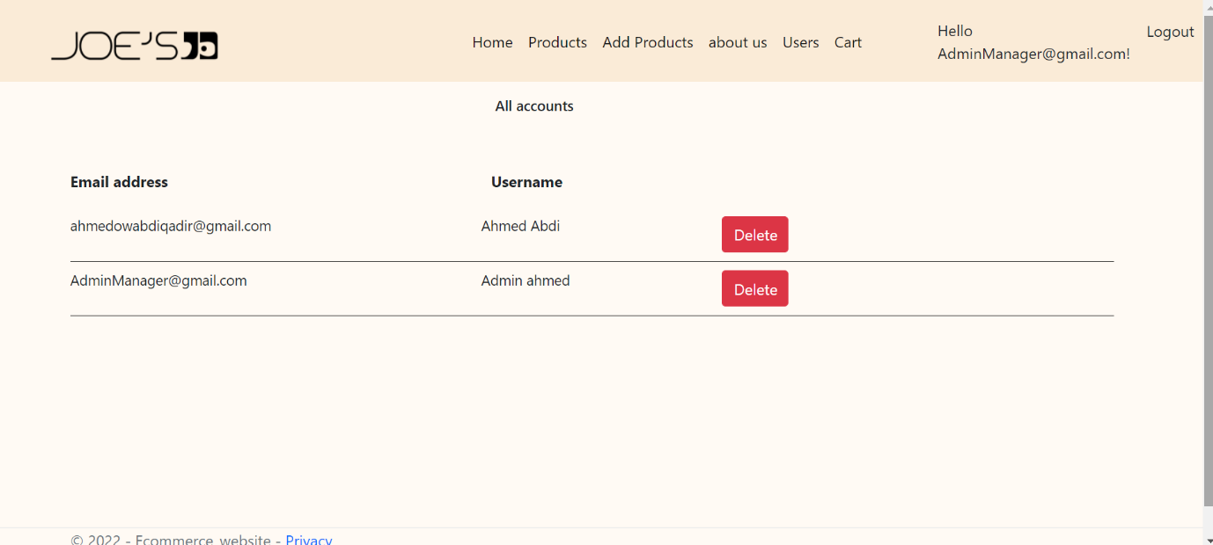

Challenges faced:

I was not able to create the shopping cart with database.

I was not able to make a functionality which allows only one user to access certain pages for example admin manager being the only user that can access it.